Dava Virgio Kertawijaya

00000056848

====================================================================

UAS Data Warehouse Lab

Exam instructions:

All your answers are combined into an archive file (.zip), which contains the following files:

a) Word file containing screenshots of the Pentaho Workbench consisting of:

i. Fill in the repository data used

ii. .XML and .JSP the OLAP Cube schema produces by Pentaho Workbench.

iii. Illustration of each output described in accordance with the answers in chapter III Data Warehouse Theory UAS IS 545.

b) .KJB file (job program) and, or .KTR file (transformation program),

c) Dataset file (SOR/input) used in answering the given question

Fill in the repository data used:

C:\00000056848-DavaVirgioKertawijaya UTS Data Warehouse Lab Odd 2022-2023\DataToyotaCorolla.xlsx

* Input Data Repository used of Product transformation

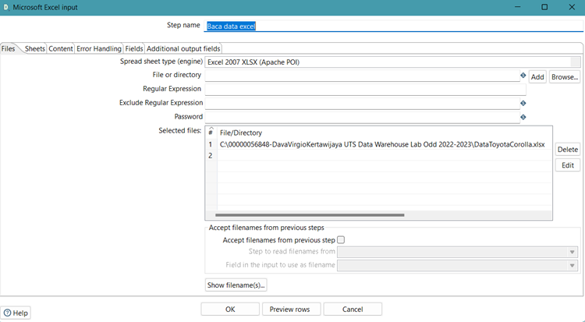

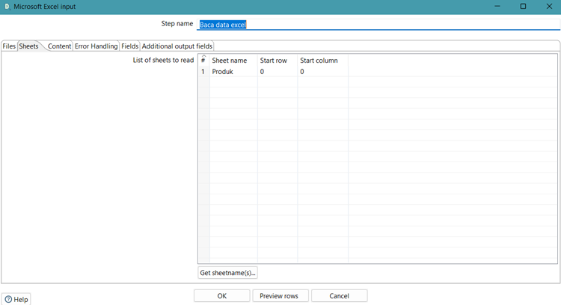

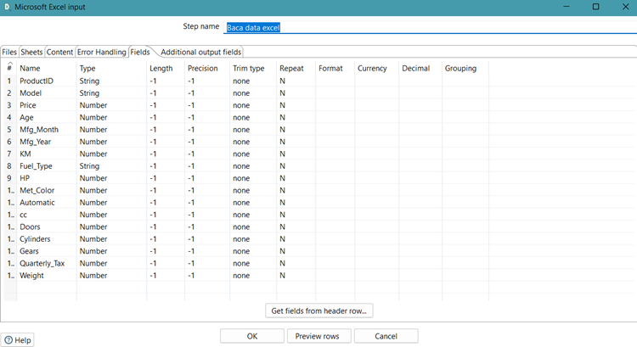

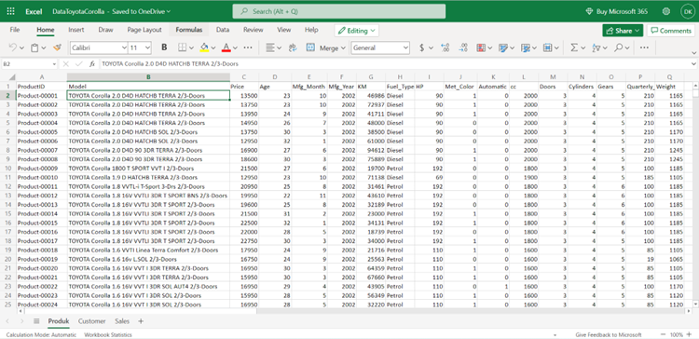

* Input Data Repository used of Sales transformation

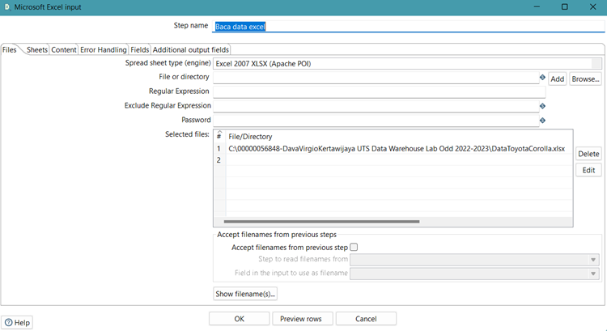

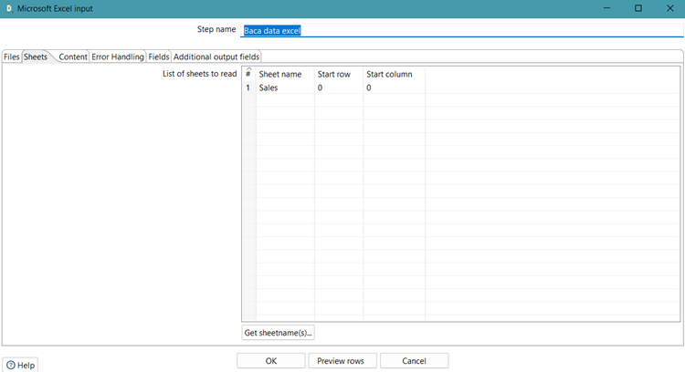

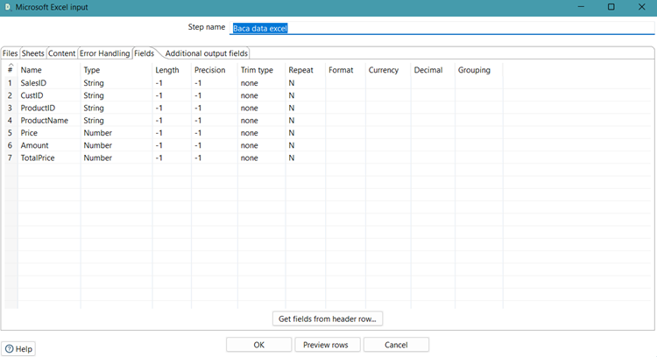

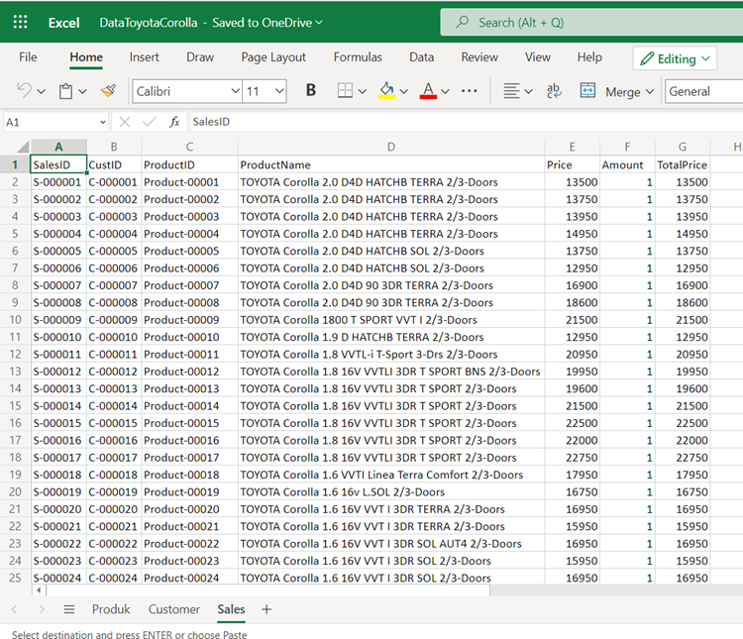

* Input Data Repository used of Customer transformation

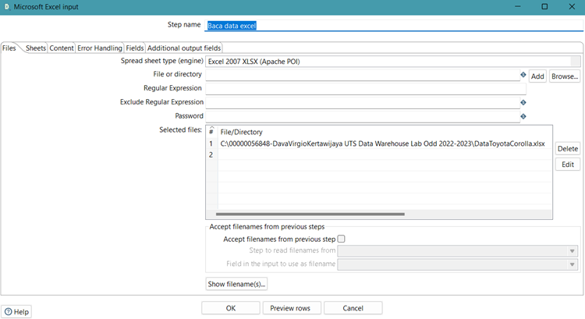

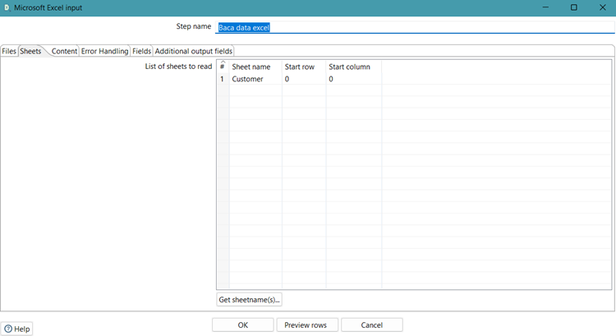

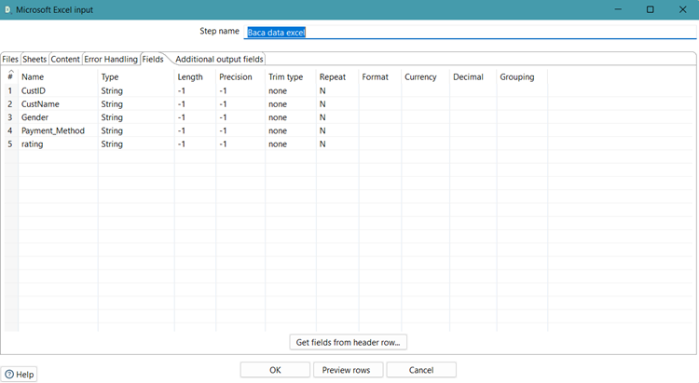

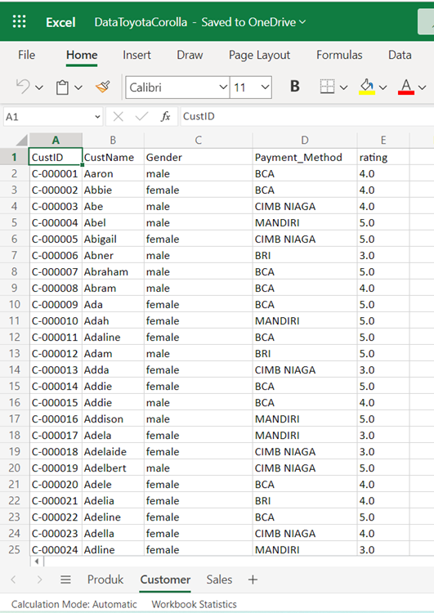

* Input Data used of Invoice transformation

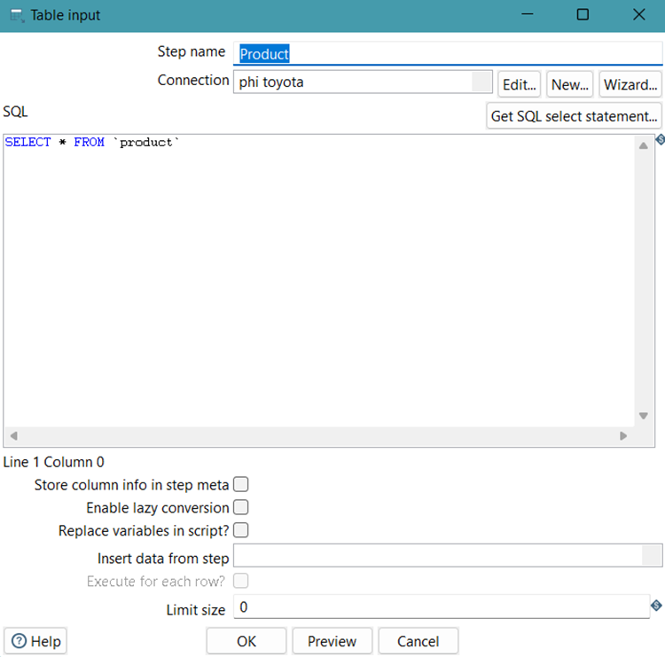

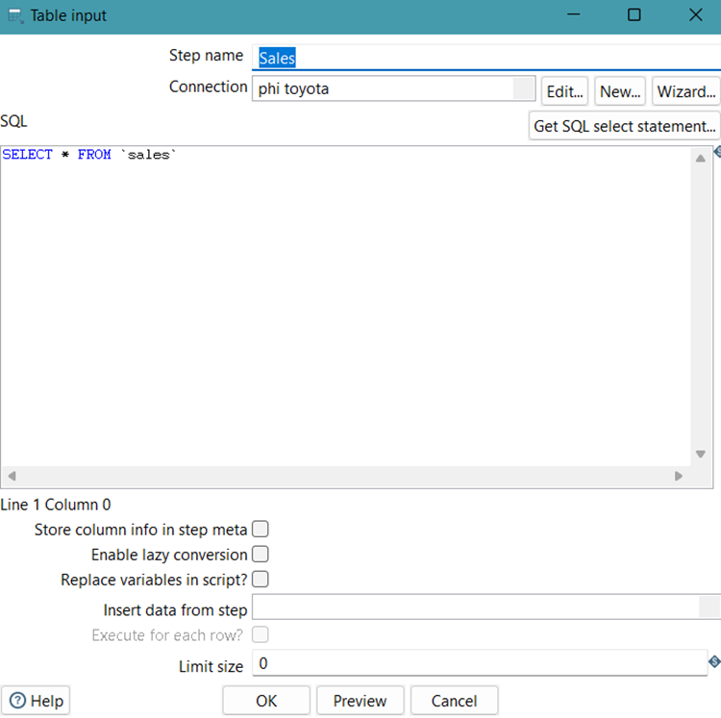

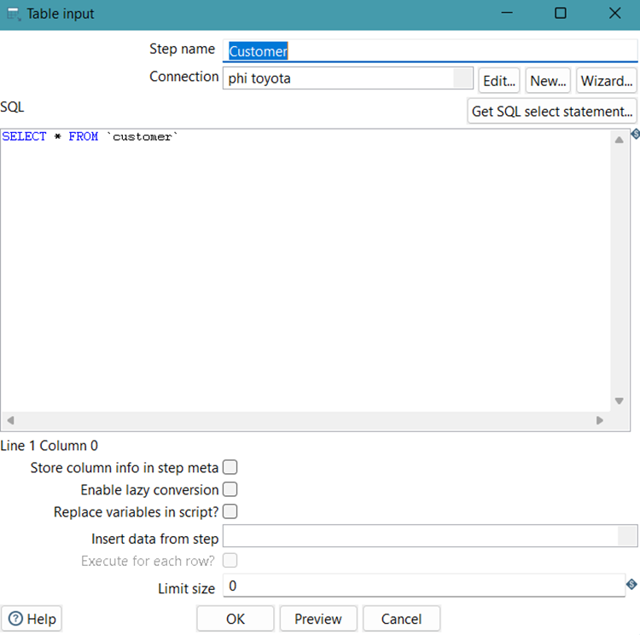

QUESTIONS:

1. CLO-2 Sub-CLO-8 and CLO-2 Sub-CLO-9, Weight 50%.

Displays the output according to the discussion described in chapter III, the answer to UAS IS545 Data Warehouse Theory, by attaching the OLAP Cube Schema file created (.xml and .jsp fles).

All attribute in schema workbench shown below:

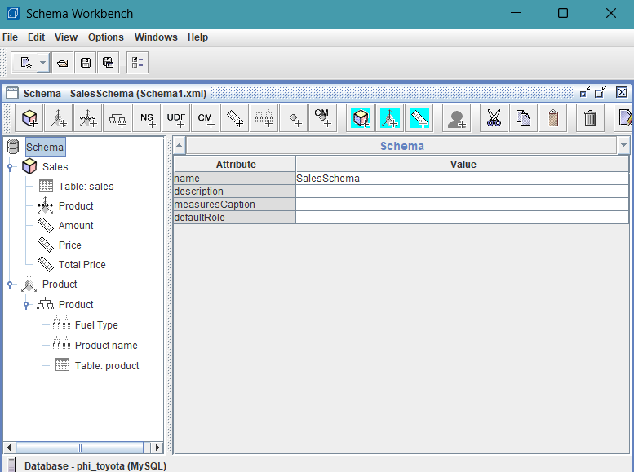

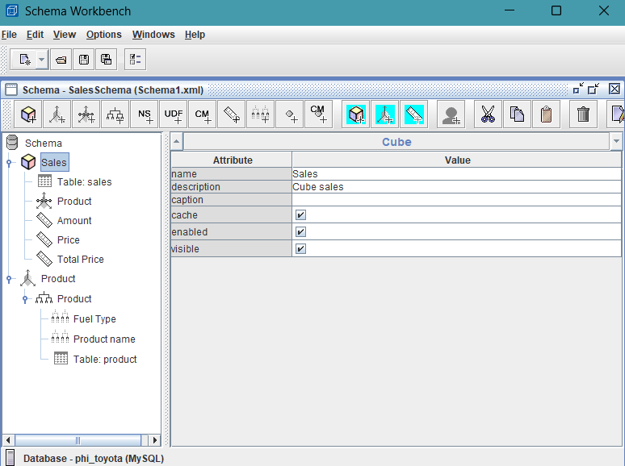

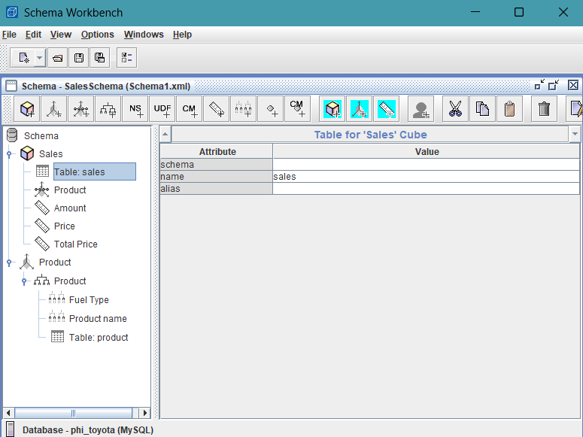

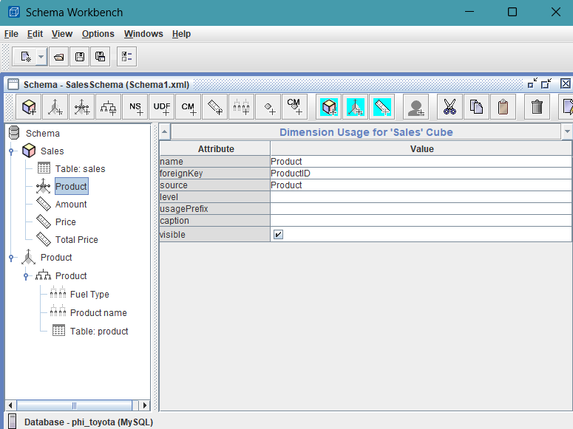

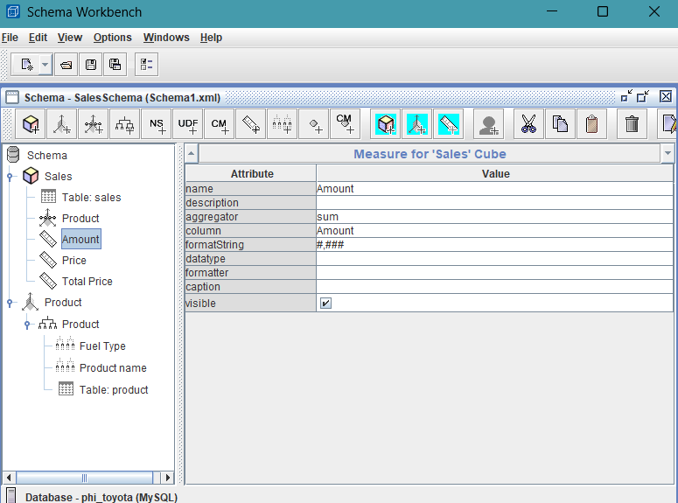

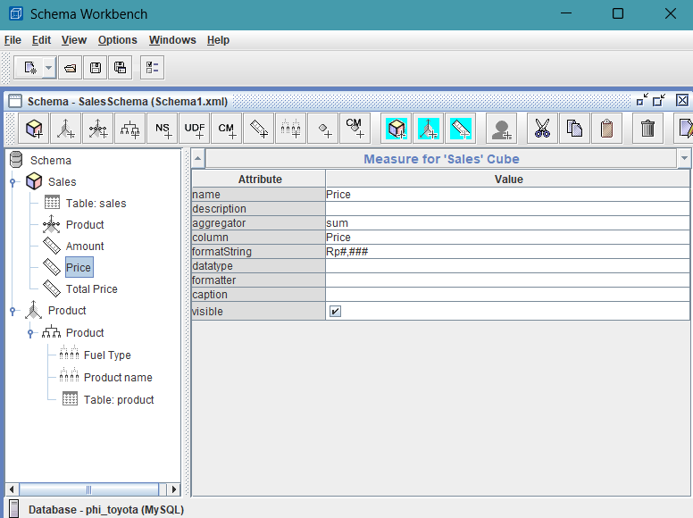

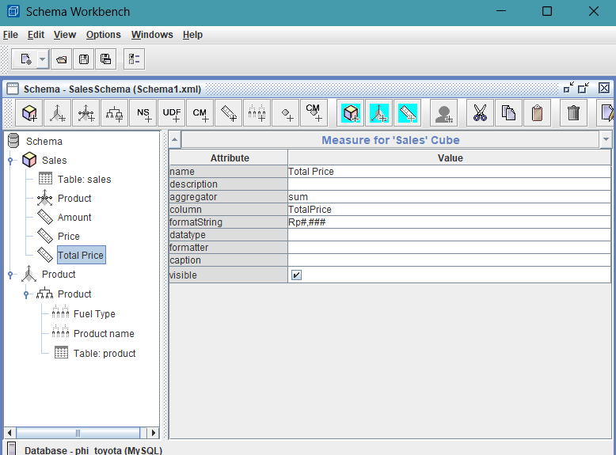

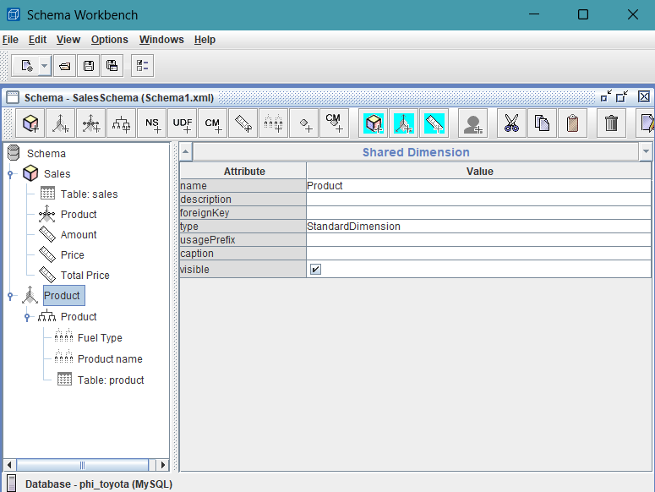

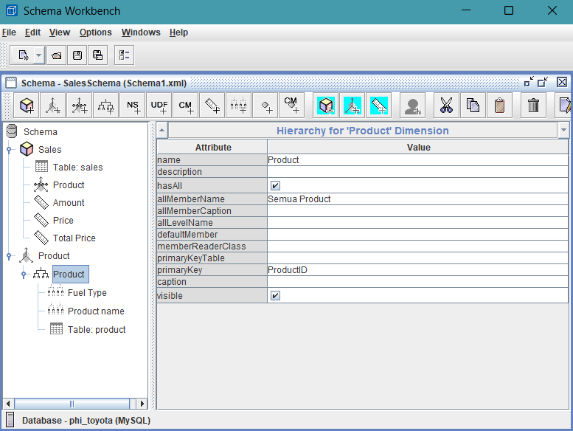

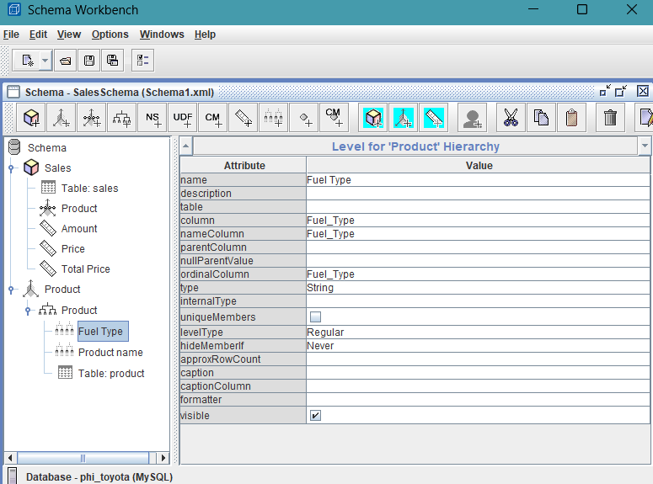

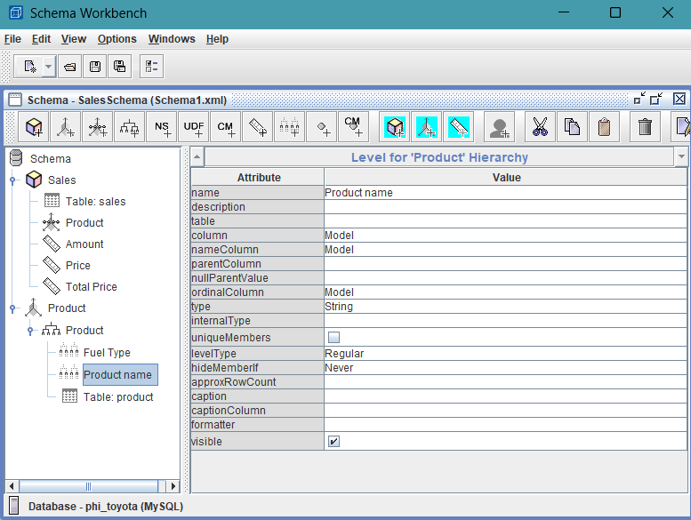

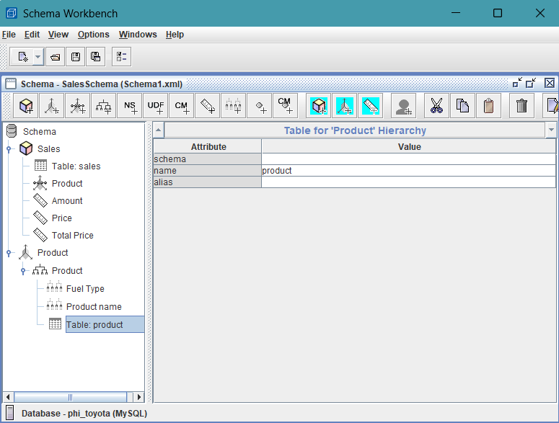

The output of OLAP Cube Schema shown below:

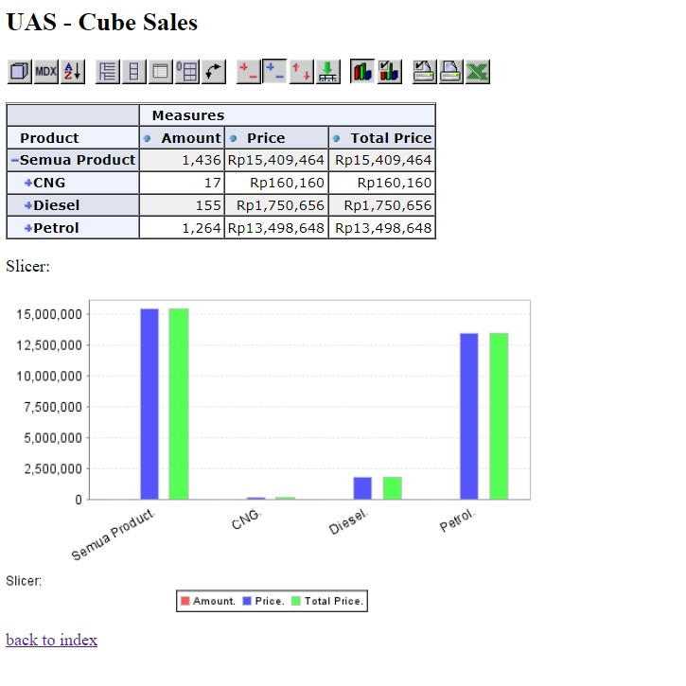

Based on OLAP analysis above, the data that already integrated and reliable, which is sales data shows that the amount of product and its price based on different fuel type product. As you can see, petrol type is the most popular product, about 8x sales compared to diesel and CNG. Imagine if the company can see clear and reliable about the analysis as shown as above. Then, it should be a super advantage for the company to make decision only just based on transaction data.

1. CLO-1 Sub-CLO-13 and CLO-2 Sub-CLO-14, Weight 50%.

Build a solution from the ETL process that you have described in the discussion of chapter III, the answer to the Data Warehouse Theory UAS IS545 Theory, by attaching the PDI Spoon programming that was created.

Based on the background in chapter 1, the following are some formulations of problems experienced by the Toyota company.

* 1. How can Toyota conduct market price analysis regarding the sales of its various product models?
  2. How does Toyota ensure that all its processes are not wasted in terms of having benefits for the resulting product?

Chapter III Problem Solving

In order to answer the formulation of the problem that is the client's needs, accurate data, as well as critical analysis are the main keys. At the point of the first problem statement, I believe that Toyota needs a data warehouse that can significantly improve the company's information flow. By determining what information is needed to analyze market prices through the star scheme, clients can perform data analysis with a clearer 'lens'. For example, consider the following star schema and database.

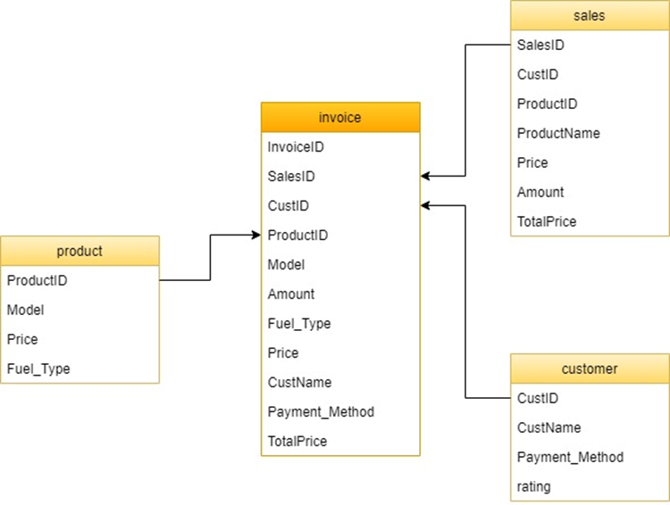

The star schema above provides more specific information about what information is needed to see the selling price of various Toyota products in the market. Meanwhile, the database below shows detailed data ready for analysis.

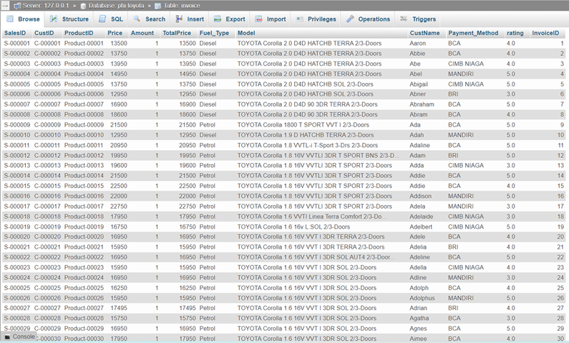

By using a data warehouse, clients can directly use this integrated data for their business needs. Then, at the second problem formulation point, the use of a data warehouse is a solution to ensure that all processes that are running are not wasted. This is because the data warehouse displays accurate and credible data, so that in conducting data analysis, clients can immediately find out which processes are less useful for the resulting product. For example, consider the product data below.

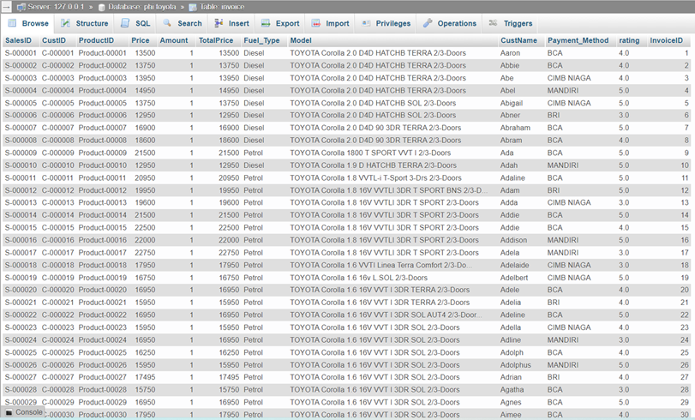

Based on the product data above, various customers from various locations made purchases of Toyota products. The feedback given from the purchase of the product is in the form of a rating from the customer. From the ratings given by customers, this data can be used as evaluation data for the products and services offered by Toyota. Thus, in the future, the sales rating of Toyota products in the eyes of customers can continue to stay close to number 5. By implementing this data warehouse, all processes will be found to have benefits or not for the products produced through data analysis.